STEP 1 : Step 1: Go to AWS Console
Open a web browser and navigate to the AWS Management Console homepage.
URL: https://aws.amazon.com/console/
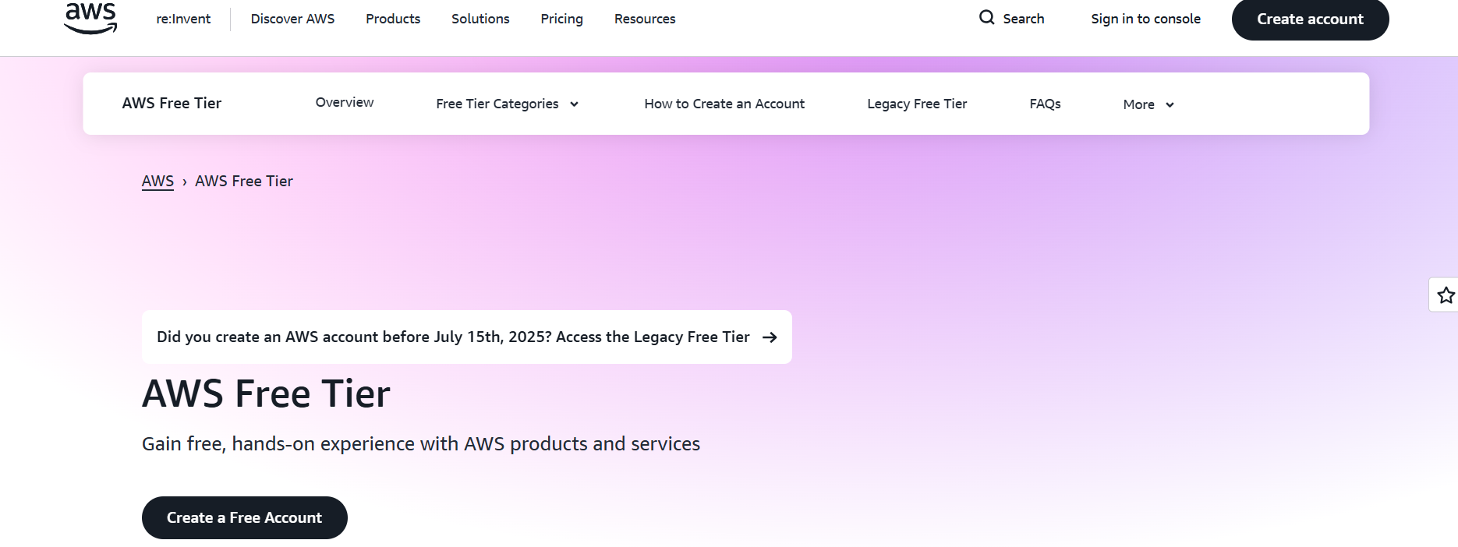

Step 2 : Step 2: Sign in to AWS Console
Here we used to give user name and password

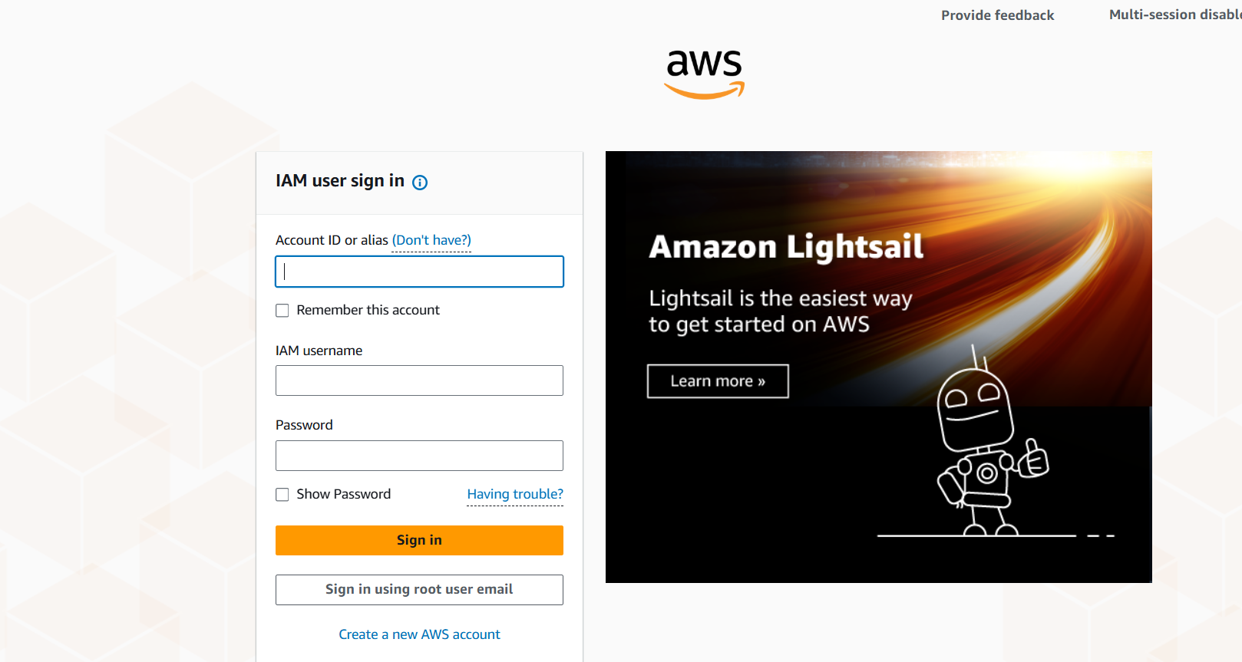

Step 3: Sign to Root user
- Here I am login with only with Email authidication to sign in.
- If applicable, complete Multi-Factor Authentication (MFA) for security to login only root user .
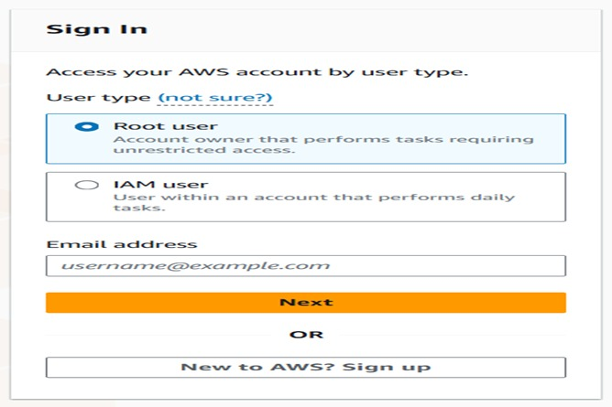
Step 4: console page
- I this console page page I can see overall cluster detils like ec2 insatnce and rds s3 buket netowrking what and all you acces the server details we are creating here

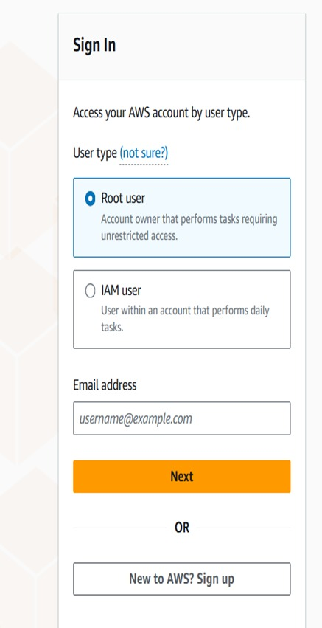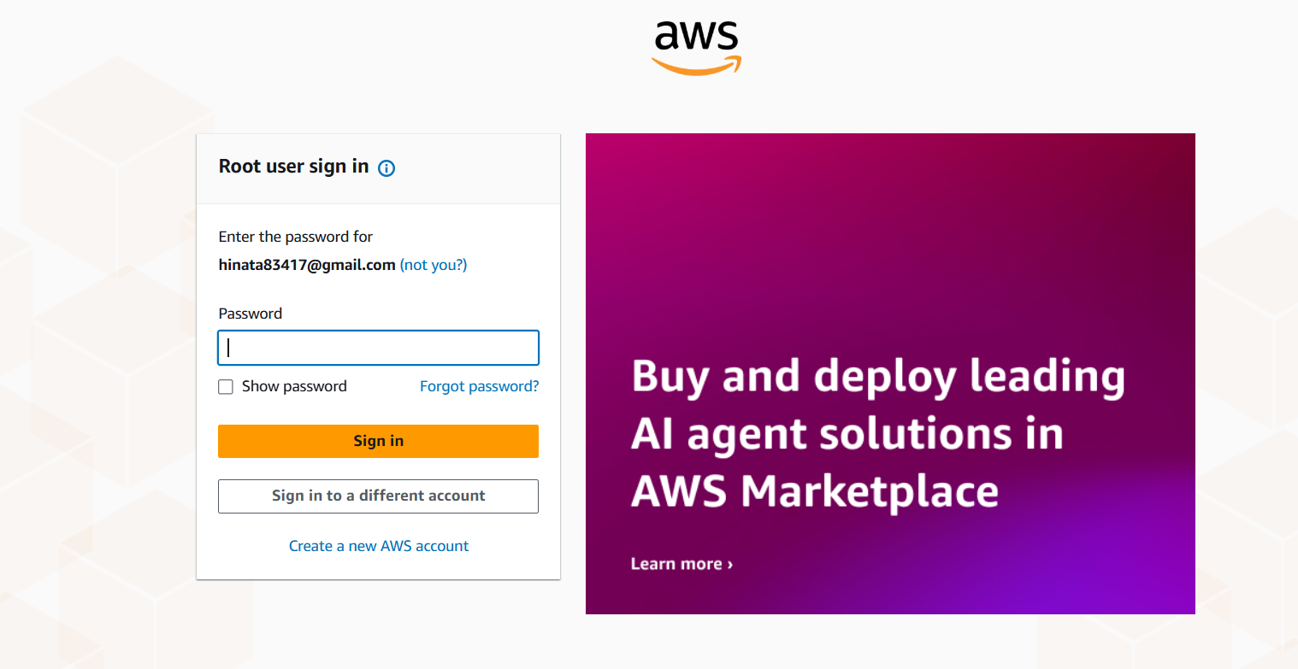

Step6: . Navigate to IAM Service
- Log in to your AWS Management Console.
- In the search bar, type IAM and select IAM from the services list.
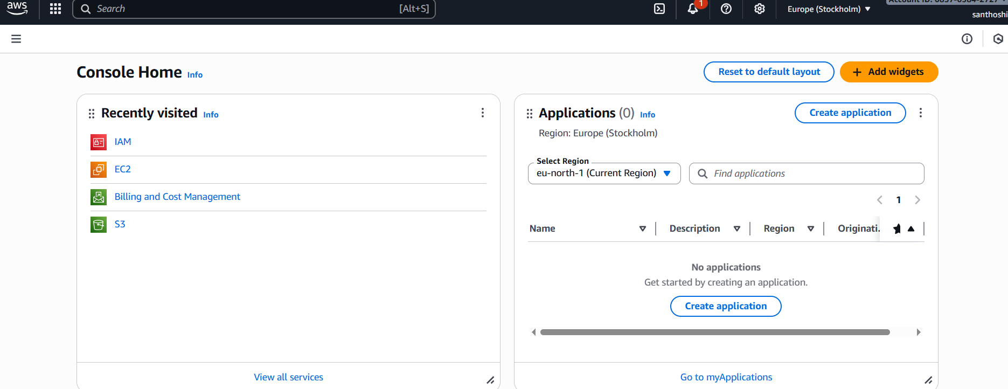

Step7: . Go to Users
- In the left navigation pane, click on Users.
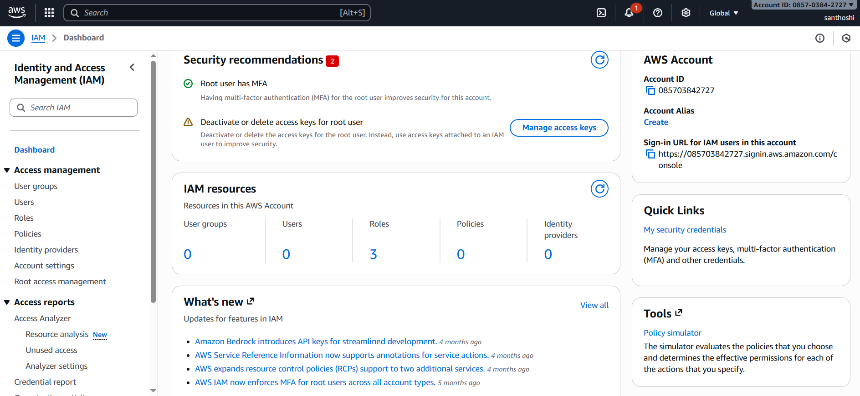

Step8: Create a New User
- Click Create user.
- Enter a username for the new user.
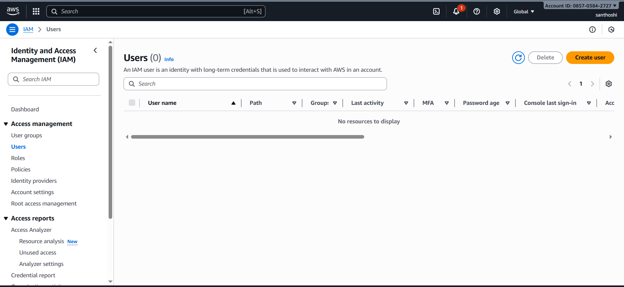

Step9: Provide Console Access
- Under Select AWS access type, choose:
  - AWS Management Console access.
- Set a custom password or allow AWS to generate one.
- (Optional) Require the user to reset password on first sign-in.
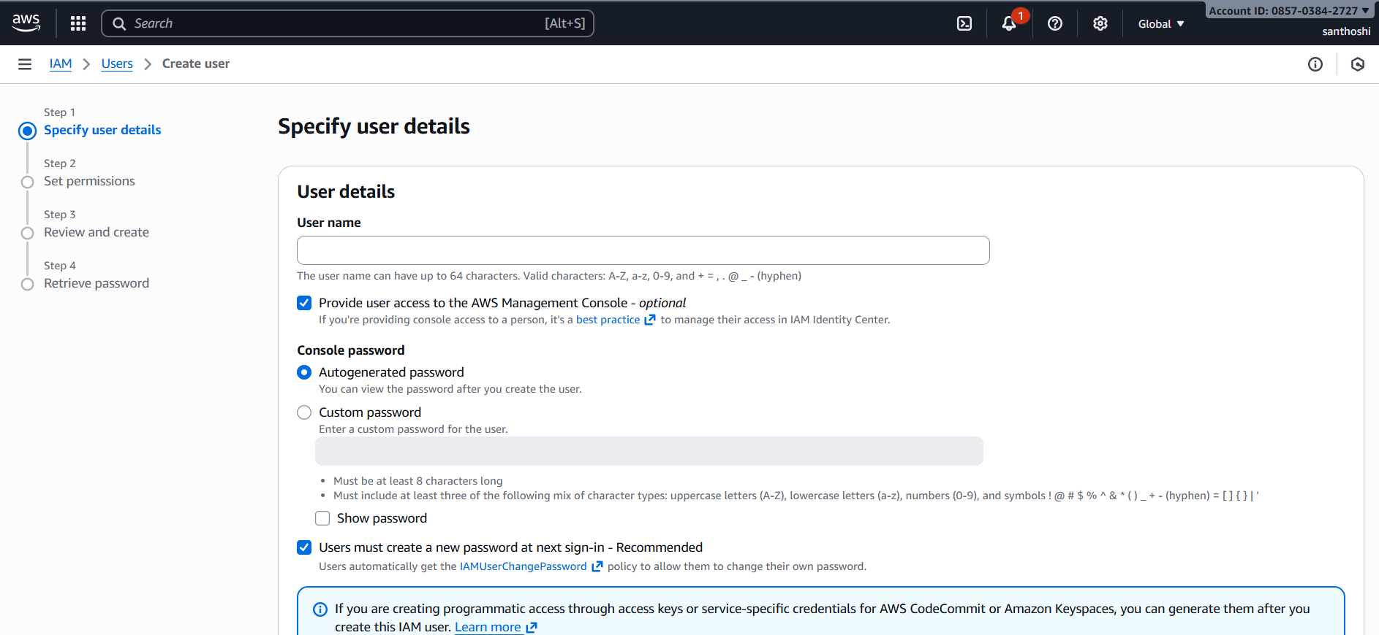

Step10: Assign Permissions
- Choose how to set permissions:
  - Attach existing policies directly (e.g., AdministratorAccess or other policies).
  - Or Add user to group if you have predefined groups.
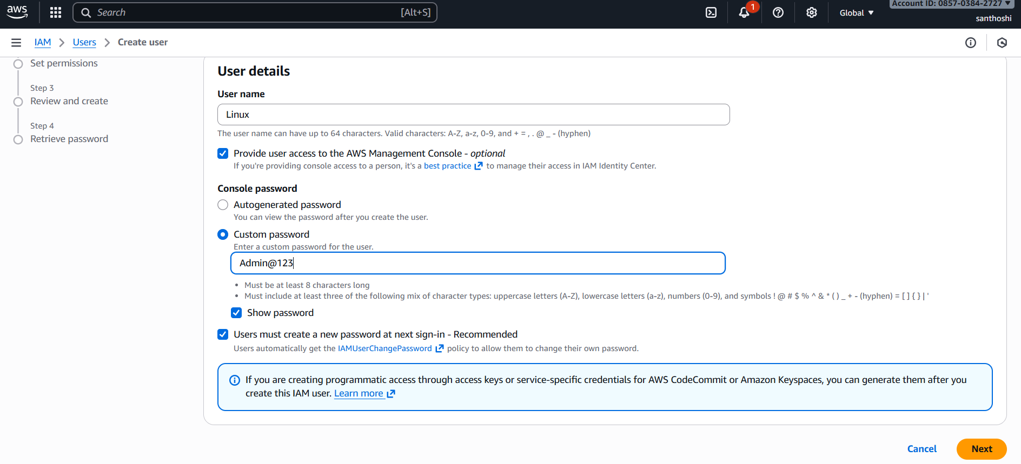

Step11 Review and Create
- Review all details.
- Click Create user
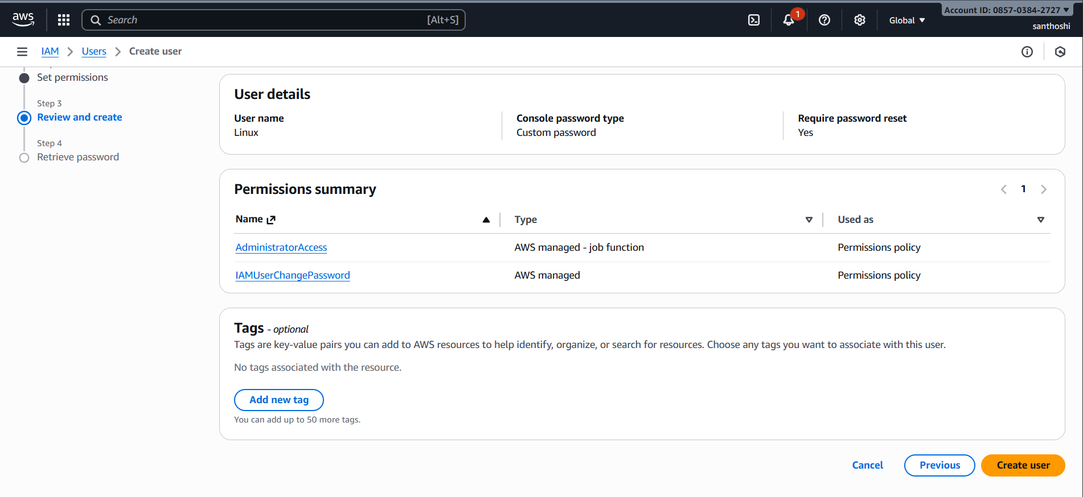

STEP12: Retrieve Sign-in Details
- After creation, you’ll see:
  - Console sign-in URL.
  - Username.
  - Password (download the .csv file or copy credentials).
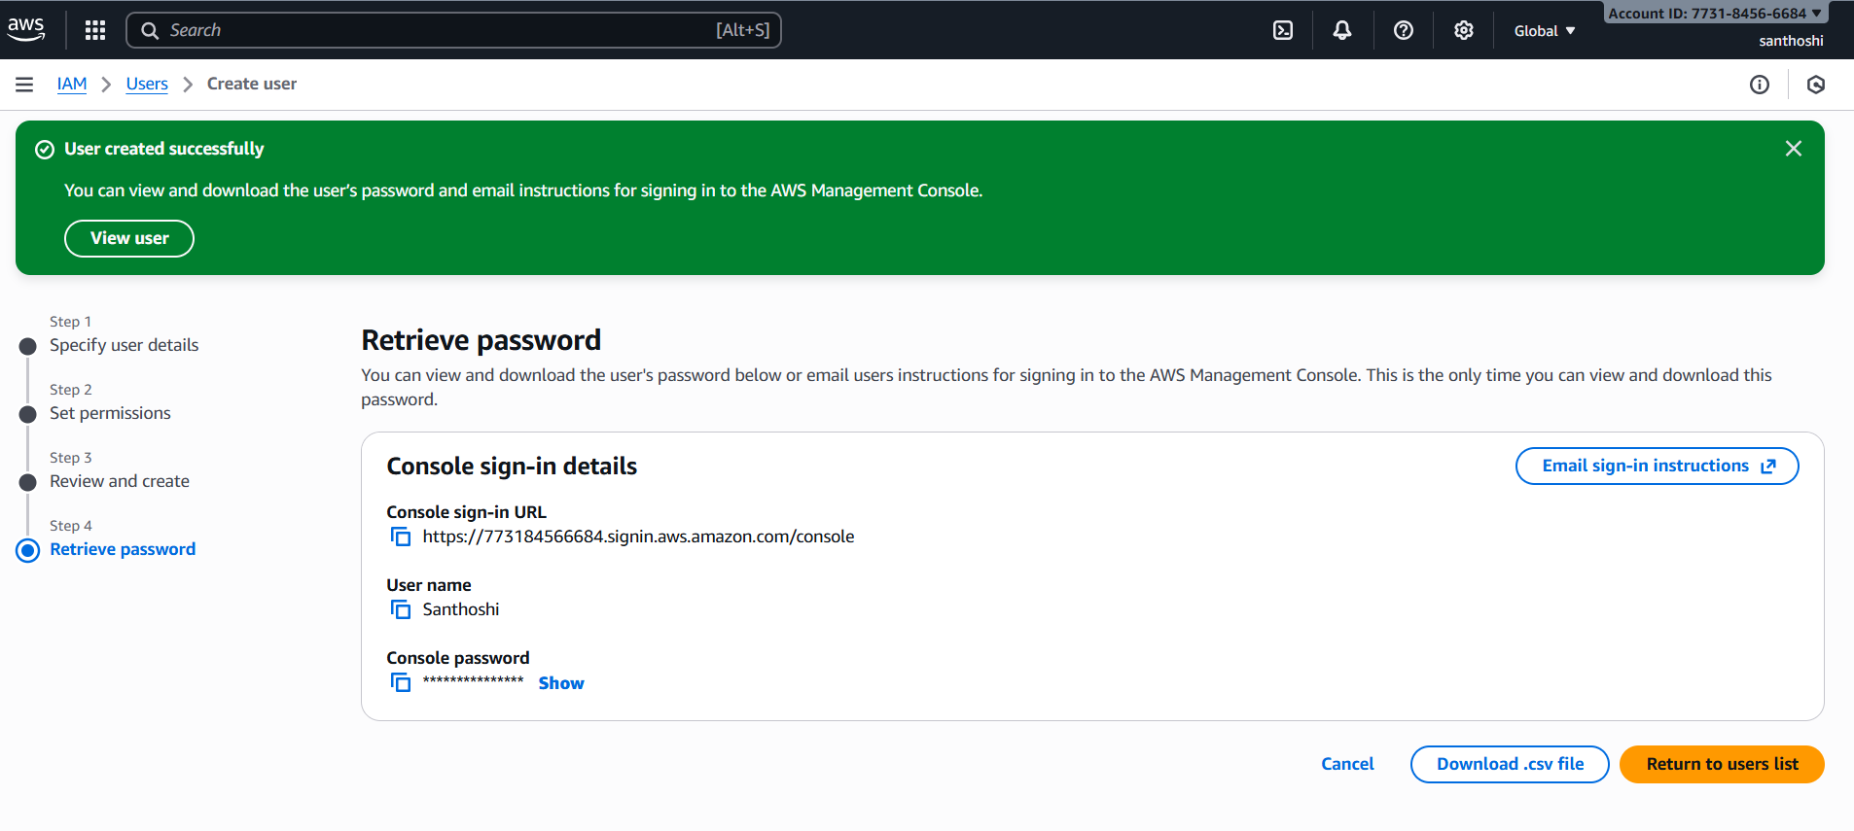Step13: Sign in to AWS Console
- Go to the provided sign-in URL.
- Enter the username and password.
- If prompted, reset password.
